Final Year Project Report
Full Unit – Final Report

Game Playing with Monte-Carlo Tree Search

Alexandra Danciu

A report submitted in part fulfilment of the degree of
BSc (Hons) in Computer Science
Supervisor: Magnus Wahlstrom

Department of Computer Science
Royal Holloway, University of London

Declaration
This report has been prepared on the basis of my own work. Where other published and unpublished source materials have been used, these have been acknowledged.

Word Count:

Student Name:

Date of Submission:

Signature:
Table of Contents
Final Year Project Report 1
Game Playing with Monte-Carlo Tree Search 1
Alexandra Danciu 1
Chapter 1: Introduction 3
1.1 Abstract 3
Chapter 2: Planning and Timescale 5
2.1 Diary 5
Chapter 3: Proof of Concepts 6
3.1 Bandit Problem 6
3.1.1 Naïve Strategies 7
3.1.2 Code 9
3.1.3 Tests and Results Table 11
3.1.4 Comparison of Algorithms 20
3.2 Connect4 21
3.2.1 Game States 22
3.2.2 Code 23
Chapter 4: Monte-Carlo Tree Search Algorithm 25
4.1 The Algorithm 25
4.2 Integration into my program 26
Chapter 5: Final Product 27
Chapter 6: Testing 28
Chapter 7: Software Engineering Techniques 29
Chapter 8: Professional Issues 30
Chapter 9: Reflection 31
Chapter 10: Conclusion 32
Chapter 11: Deploying Code 33
Bibliography 34

Introduction
[This section must include a description of how you think that the work involved in your project will help in your future career.]
The primary aim of this project is to design and implement a game-playing program using the Monte-Carlo Tree Search (MCTS) algorithm, evaluating its effectiveness through experimental analysis. The AI opponent will play Connect4 against real players, it should be able to showcase the decision-making capabilities of the algorithm well and be a good opponent.
Early objectives include creating proof-of-concept programs. One of these will be to solve bandit problems using Upper Confidence Bound (UCB) methods and compare these strategies with naive approaches. This comes into play in the simulation section of MCTS, where the issue at hand looks a lot like a bandit problem, UCB can be implemented in this section to explore the unsure parts of the tree and return the best arm.
Another proof of concept is a basic Connect4 game that allows two human players to play the game. This will be modified next term to have a GUI interface and allow players to choose to either play two-player or vs AI.

Abstract
The goal of this project is to design and implement a game-playing program using Monte-Carlo Tree Search. The game I have decided to implement using the MCTS is Connect4; Connect4 is a two-player strategy board game where players take turns dropping coloured discs into a grid to be the first to get four in a row.
Monte-Carlo Tree Search is an innovative heuristic search method that has revolutionized decision-making in complex game trees. MCTS has demonstrated remarkable success in challenging domains, such as Go, where traditional algorithms like alpha-beta pruning struggle due to high branching factors.
The main motivation behind this project is to create a game-playing program that can successfully win a game of Connect4. The algorithm for this program should play more efficiently than if using alpha-beta pruning. I will also be creating a user-friendly interface, the program will allow players to experience the capabilities of the AI firsthand, enhancing their understanding of MCTS and its practical implications in game strategy.
These are some of the individual project goals I have for this project:
- Implementation of Bandit Problem Solver:
  - The project will commence with the development of proof-of-concept programs to tackle bandit problems, assessing the effectiveness of Upper Confidence Bound (UCB) methods against naive strategies.
- Human-Only Gameplay:
  - Create a functional program allowing two players to play Connect4 without AI involvement. This will lay out the foundations for understanding game mechanics and state transitions, and for creating an easy-to-use and user-friendly GUI.
- Game Rules Documentation:
  - Formulate semi-formal documentation detailing the rules of Connect4, including state representations and allowable transitions. This ensures clarity in the game design.
- Development of MCTS Algorithm:
  - Implement the MCTS algorithm, encapsulating its core components, selection, expansion, simulation, and backpropagation, within a well-structured, object-oriented design.
- User Interface Design:
  - Design and implement a GUI that supports both human VS human and human VS AI gameplay. The interface will focus on user experience, providing intuitive controls and visual feedback.
- Experimental Evaluation:
  - Conduct extensive experimental evaluations to analyse the performance of MCTS based on various parameters, such as search depth and the number of rollouts.
- Software Engineering Documentation:
  - Compile a comprehensive report detailing the software engineering process, design decisions, and challenges faced during development. This will include discussions on the theoretical foundations of bandit processes and MCTS, as well as justifications for the GUI design.

Planning and Timescale
In terms of planning, I had my timeline and plan for both terms in my Project Plan. In said plan, I had broken up my weeks into four blocks.
The first block was met, it was to do with the project plan and spending the first two weeks doing that, which I did according to my diary and submitted the work.
The second block was not met, as you can see from the diary below, I did not do any work from October 5th to November 4th. This was due to poor time management on my part, I was doing coursework for my other classes and had neglected this course. I set up a meeting with my supervisor and so began my catch-up. I spent the next two weeks completing the bandit proof of concept code and working on the report. I then began work on the Connect4 proof of concept and reports, keeping in consistent communication with my supervisor. I did get everything done in time and managed to catch up to my original plan, completed block four as planned.
My goal for next term will be to start this course first, ensuring I follow the plan I set out for myself and that I do not get behind on my work again.

Diary

Proof of Concepts

Bandit Problem
Bandit Problems are statistical problems that involve trying to gain as many points over a limited time as possible. There will be multiple places to visit that include an unknown number of points each. The goal is to find a balance between exploring and exploiting.
Exploring means going out to new places and figuring out how many points they can give you, most of the time the points will vary at different times so the average number of points would be best.
Exploiting is going to the place where you know the average number of points given is high and you are likely to gather the most points here.
One example would be going to a restaurant to eat. Say you had 300 days, and you wanted to go out to eat each night at 3 different restaurants. Each restaurant will give you a certain amount of happiness to go eat there each night. One restaurant could give you an average of 10 happiness with a deviation of 2.5 each way, a second restaurant could give you 8 happiness on average with a 2 deviation each way, and the third restaurant offers an average of 5 happiness with a 12.5 deviation.
You want to have a balance between going to a restaurant and trying its menu and seeing how much happiness it gives you and going to your favourite restaurant that you are more confident will make you happy.

Naïve Strategies
There are several different algorithms you can use to solve the bandit problem, however, the efficiency of some of them compared to other, better, algorithms are lacking.

Explore Only
One of these less efficient algorithms that still gets the job done is Explore Only. With this algorithm the entire 300 days is spent exploring and picking random restaurants to dine at. By the end, you have spent a considerable amount of time at the wrong restaurants and have lost some points on the way. Each restaurant will end up having an equal 100 days spent at them.

Exploit Only
Another inefficient, naïve algorithm would be Exploit Only, which is similar to Explore Only where it does only one-half of the explore/exploit in the problem.
With this algorithm you will use the first three days to visit each restaurant once and which restaurant gave you the highest happiness level you will visit for the rest of the 297 days.
While this may seem like an ok algorithm, the happiness points given by each restaurant have a deviation. On day one you may visit the best restaurant, number 1, and get a low deviation that gives you 7 instead of the average 10, and then you go to restaurant 2 on day 2 and get an 8. You would then continue to go to Restaurant 2 for the remainder of the days and would only be visiting the second-best restaurant, lowering your chances for higher total happiness points.

E-Greedy
This is one of the better algorithms that could be used to generate decent results.
With this algorithm you start by denoting an E value, say E = 10%.
What this means is that each day, there is now a 10% chance that you will visit a random restaurant and a 90% chance that you will visit the restaurant that has historically given you the most happiness points. These exploit days, the 10% chance that you visit a random restaurant, gives you more evidence of which restaurant is the best. It will either ensure that you switch restaurants to the best one in the case that the first time you went to one a deviation happened, or it will make you more confident that the restaurant you are currently going to is the best one.
The issue with this algorithm is that its performance depends on the chosen epsilon value and the value of the possible deviations.

Upper Confidence Bound (UCB)
This is one of the best algorithms used to solve bandit problems. It is great at balancing the exploration of new arms or arms with low confidence and exploiting arms with known high values or arms with high confidence values as they have been visited frequently. This algorithm works similarly to E-Greedy. The strategy is that:
At each time T, pick point R, such that
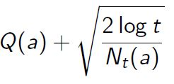
mean of R + √ 2 * current time T / number of times visited R

With this algorithm, each time an arm needs to be selected, each arm’s UCB value is calculated using the equation above, and the highest value is selected. This works similarly to E-Greedy in the way that the arm with the highest value is visited more frequently as it gives back the most points but the calculation of the UCB also means that other arms are visited at regular points and in a fair way; it is not left to random chance. The success of E-Greedy depends highly on the value of E, which UCB does not struggle with.

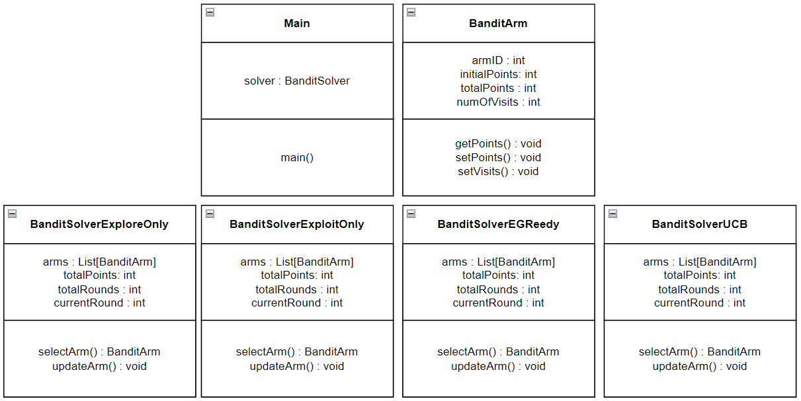
Code
The coding for this proof of concept started with the UML design above. We have the BanditArm class that creates instances of the arms equipped with points and numbers of visits and some methods to get and set variables. These arms represent the restaurants in the example used above. Then, we have the four BanditSolver…() classes that represent the four different algorithms used to solve the bandit problem. In this basic version of the UML, all of the classes had the same basic variables and methods that later changed as I coded. Finally, we have the main class that initialises all of the classes sets up the arms and prints out the results of running each solver class.
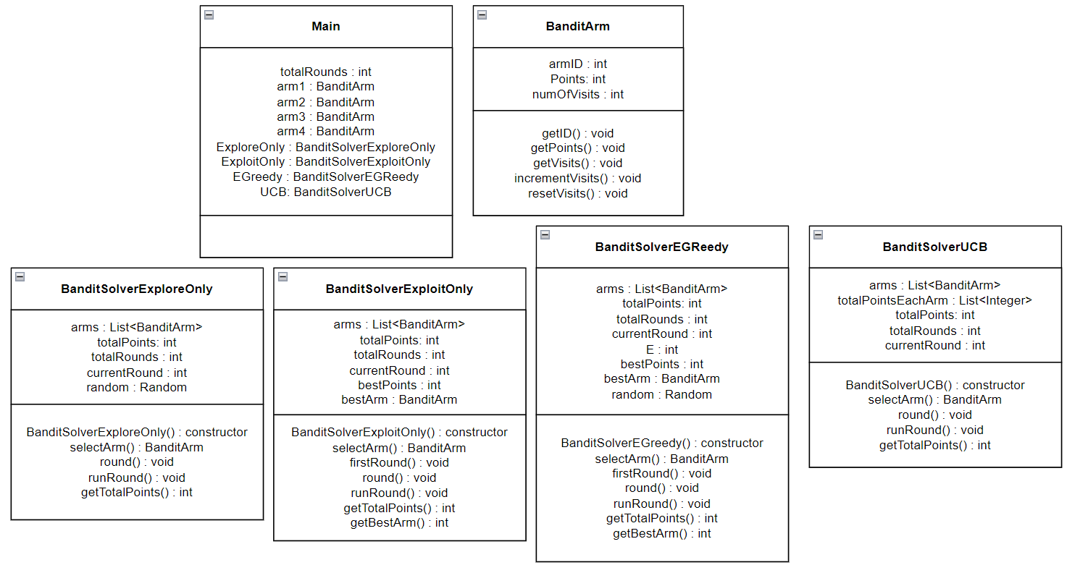
Above is the final version of the UML that copies the exact layout of the final code for the proof of concept. The main structure change was in the solver classes, the original UML had two classes for selectArm() and updateArm(), however, I decided to break this down further into three classes, selectArm(), round() and runRound().
I chose to do this because I thought I was a better general fit for all the different algorithms. selectArm() contains the code for the actual algorithm within each arm. round() simply runs selectArm() and then increments the visits on the arm and adds the points to the total points. And runRound() checks whether the current round is equal to the total number of rounds before running another round.
Aside from the main structure changes more changes were made on a class basis, depending on what the algorithms needed. Such as the E variable for the E-Greedy class, firstRound() for the exploit only class and random was implemented for the explore only and E-Greedy class.
The Main was changed appropriately to accommodate the initialisation of all the classes and instances of the arms. Main was mostly used to change the values in the arms and other variables such as the total rounds and E for the tests done for the comparison of the efficiency of the algorithms under different states.

Tests and Results Table
Round | Parameters | 1. Explore  Only | 2. Exploit Only | 3. E-Greedy | 4. UBC | Total Points
1 | Total Rounds: 100  Arms: 4  Arm1: 10, 4  Arm2: 5, 5  Arm3: 7, 3  Arm4: 8, 2  Base,  Normal parameters | Arm1: 24  Arm2: 23  Arm3: 35  Arm4: 18 | Arm1: 1  Arm2: 97  Arm3: 1  Arm4: 1 | Arm1: 83  Arm2: 8  Arm3: 6  Arm4: 3 | Arm1: 96  Arm2: 2  Arm3: 1  Arm4: 1 | 1: 645  2: 444  3: 857  4: 984
1 |  | Arm1: 26  Arm2: 24  Arm3: 23  Arm4: 27 | Arm1: 97  Arm2: 1  Arm3: 1  Arm4: 1 | Arm1: 84  Arm2: 5  Arm3: 4  Arm4: 7 | Arm1: 90  Arm2: 1  Arm3: 7  Arm4: 2 | 1: 700  2: 883  3: 932  4: 983
1 |  | Arm1: 21  Arm2: 31  Arm3: 25  Arm4: 23 | Arm1: 1  Arm2: 1  Arm3: 1  Arm4: 97 | Arm1: 88  Arm2: 3  Arm3: 6  Arm4: 3 | Arm1: 97  Arm2: 1  Arm3: 1  Arm4: 1 | 1: 649  2: 759  3: 964  4: 931
1 |  | Arm1: 23  Arm2: 25  Arm3: 22  Arm4: 30 | Arm1: 1  Arm2: 97  Arm3: 1  Arm4: 1 | Arm1: 68  Arm2: 6  Arm3: 2  Arm4: 24 | Arm1: 95  Arm2: 1  Arm3: 2  Arm4: 2 | 1: 660  2: 411  3: 842  4: 907
1 |  | Arm1: 23  Arm2: 21  Arm3: 25  Arm4: 31 | Arm1: 1  Arm2: 1  Arm3: 1  Arm4: 97 | Arm1: 92  Arm2: 3  Arm3: 2  Arm4: 3 | Arm1: 97  Arm2: 1  Arm3: 1  Arm4: 1 | 1: 662  2: 724  3: 918  4: 949
2 | Total Rounds: 500  Arms: 4  Arm1:10, 4  Arm2: 5, 5  Arm3: 7, 3  Arm4: 8, 2  A lot more rounds run. | Arm1: 119  Arm2: 123  Arm3: 124  Arm4: 134 | Arm1: 1  Arm2: 1  Arm3: 1  Arm4: 497 | Arm1: 459  Arm2: 12  Arm3: 11  Arm4: 18 | Arm1: 495  Arm2: 1  Arm3: 1  Arm4: 3 | 1: 3522  2: 3777  3: 4672  4: 4640
2 |  | Arm1: 122  Arm2: 146  Arm3: 99  Arm4: 133 | Arm1: 1  Arm2: 1  Arm3: 1  Arm4: 497 | Arm1: 110  Arm2: 47  Arm3: 315  Arm4: 28 | Arm1: 492  Arm2: 2  Arm3: 1  Arm4: 5 | 1: 3448  2: 3827  3: 3569  4: 4693
2 |  | Arm1: 105  Arm2: 134  Arm3: 147  Arm4: 114 | Arm1: 1  Arm2: 1  Arm3: 1  Arm4: 497 | Arm1: 182  Arm2: 134  Arm3: 147  Arm4: 37 | Arm1: 478  Arm2: 2  Arm3: 2  Arm4: 18 | 1: 3488  2: 3712  3: 3622  4: 4698
2 |  | Arm1: 105  Arm2: 134  Arm3: 147  Arm4: 114 | Arm1: 1  Arm2: 1  Arm3: 1  Arm4: 497 | Arm1: 182  Arm2: 134  Arm3: 147  Arm4: 37 | Arm1: 478  Arm2: 2  Arm3: 2  Arm4: 18 | 1: 3488  2: 3712  3: 3622  4: 4698
2 |  | Arm1: 132  Arm2: 105  Arm3: 128  Arm4: 135 | Arm1: 497  Arm2: 1  Arm3: 1  Arm4: 1 | Arm1: 82  Arm2: 12  Arm3: 390  Arm4: 16 | Arm1: 492  Arm2: 2  Arm3: 2  Arm4: 4 | 1: 3564  2: 4581  3: 3567  4: 4777
3 | Total Rounds: 20  Arms: 4  Arm1:10, 4  Arm2: 5, 5  Arm3: 7, 3  Arm4: 8, 2  A lot fewer rounds run. | Arm1: 9  Arm2: 3  Arm3: 4  Arm4: 4 | Arm1: 17  Arm2: 1  Arm3: 1  Arm4: 1 | Arm1: 1  Arm2: 1  Arm3: 1  Arm4: 17 | Arm1: 13  Arm2: 1  Arm3: 4  Arm4: 2 | 1: 126  2: 154  3: 149  4: 174
3 |  | Arm1: 7  Arm2: 3  Arm3: 1  Arm4: 9 | Arm1: 17  Arm2: 1  Arm3: 1  Arm4: 1 | Arm1: 3  Arm2: 2  Arm3: 14  Arm4: 1 | Arm1: 5  Arm2: 2  Arm3: 12  Arm4: 1 | 1: 179  2: 172  3: 136  4: 152
3 |  | Arm1: 6  Arm2: 5  Arm3: 5  Arm4: 4 | Arm1: 17  Arm2: 1  Arm3: 1  Arm4: 1 | Arm1: 1  Arm2: 1  Arm3: 17  Arm4: 1 | Arm1: 14  Arm2: 1  Arm3: 1  Arm4: 4 | 1: 120  2: 146  3: 144  4: 185
3 |  | Arm1: 3  Arm2: 5  Arm3: 6  Arm4: 6 | Arm1: 1  Arm2: 1  Arm3: 17  Arm4: 1 | Arm1: 8  Arm2: 2  Arm3: 2  Arm4: 8 | Arm1: 17  Arm2: 1  Arm3: 1  Arm4: 1 | 1: 125  2: 139  3: 150  4: 175
3 |  | Arm1: 4  Arm2: 6  Arm3: 8  Arm4: 2 | Arm1: 1  Arm2: 1  Arm3: 17  Arm4: 1 | Arm1: 16  Arm2: 2  Arm3: 1  Arm4: 1 | Arm1: 1  Arm2: 1  Arm3: 2  Arm4: 16 | 1: 119  2: 109  3: 158  4: 139
4 | Total Rounds: 100  Arms: 8  Arm1:10, 4  Arm2: 5, 5  Arm3: 7, 3  Arm4: 8, 2  Arm5: 6, 4  Arm6: 3, 3  Arm7: 4, 2  Arm8: 1, 5  Double the number of arms. | Arm1: 16  Arm2: 15  Arm3: 12  Arm4: 15  Arm5: 13  Arm6: 9  Arm7: 4  Arm8: 16 | Arm1: 93  Arm2: 1  Arm3: 1  Arm4: 1  Arm5: 1  Arm6: 1  Arm7: 1  Arm8: 1 | Arm1: 82  Arm2: 3  Arm3: 3  Arm4: 3  Arm5: 1  Arm6: 1  Arm7: 2  Arm8: 5 | Arm1: 90  Arm2: 2  Arm3: 1  Arm4: 3  Arm5: 1  Arm6: 1  Arm7: 1  Arm8: 1 | 1: 570  2: 897  3: 887  4: 912
4 |  | Arm1: 16  Arm2: 12  Arm3: 8  Arm4: 14  Arm5: 16  Arm6: 11  Arm7: 13  Arm8: 10 | Arm1: 1  Arm2: 1  Arm3: 1  Arm4: 1  Arm5: 1  Arm6: 1  Arm7: 93  Arm8: 1 | Arm1: 58  Arm2: 1  Arm3: 29  Arm4: 2  Arm5: 2  Arm6: 5  Arm7: 2  Arm8: 1 | Arm1: 91  Arm2: 1  Arm3: 1  Arm4: 3  Arm5: 1  Arm6: 1  Arm7: 1  Arm8: 1 | 1: 552  2: 341  3: 818  4: 846
4 |  | Arm1: 10  Arm2: 9  Arm3: 9  Arm4: 16  Arm5: 16  Arm6: 10  Arm7: 16  Arm8: 14 | Arm1: 1  Arm2: 1  Arm3: 1  Arm4: 1  Arm5: 1  Arm6: 1  Arm7: 93  Arm8: 1 | Arm1: 81  Arm2: 2  Arm3: 3  Arm4: 3  Arm5: 3  Arm6: 2  Arm7: 3  Arm8: 3 | Arm1: 74  Arm2: 2  Arm3: 2  Arm4: 16  Arm5: 3  Arm6: 1  Arm7: 1  Arm8: 1 | 1: 558  2: 350  3: 873  4: 877
4 |  | Arm1: 13  Arm2: 15  Arm3: 11  Arm4: 15  Arm5: 13  Arm6: 12  Arm7: 11  Arm8: 10 | Arm1: 1  Arm2: 1  Arm3: 1  Arm4: 1  Arm5: 1  Arm6: 1  Arm7: 1  Arm8: 93 | Arm1: 13  Arm2: 1  Arm3: 1  Arm4: 2  Arm5: 4  Arm6: 76  Arm7: 2  Arm8: 1 | Arm1: 77  Arm2: 6  Arm3: 4  Arm4: 6  Arm5: 3  Arm6: 1  Arm7: 1  Arm8: 2 | 1: 488  2: 185  3: 419  4: 863
4 |  | Arm1: 10  Arm2: 8  Arm3: 17  Arm4: 12  Arm5: 21  Arm6: 12  Arm7: 12  Arm8: 8 | Arm1: 93  Arm2: 1  Arm3: 1  Arm4: 1  Arm5: 1  Arm6: 1  Arm7: 1  Arm8: 1 | Arm1: 2  Arm2: 1  Arm3: 2  Arm4: 88  Arm5: 3  Arm6: 1  Arm7: 1  Arm8: 2 | Arm1: 88  Arm2: 1  Arm3: 6  Arm4: 1  Arm5: 1  Arm6: 1  Arm7: 1  Arm8: 1 | 1: 512  2: 968  3: 708  4: 894
5 | Total Rounds: 100  Arms: 4  Arm1: 10, 4  Arm2: 20, 5  Arm3: 30, 3  Arm4: 40, 2  Greatly increase the distance between points given. | Arm1: 17  Arm2: 30  Arm3: 31  Arm4: 22 | Arm1: 1  Arm2: 1  Arm3: 1  Arm4: 97 | Arm1: 5  Arm2: 5  Arm3: 5  Arm4: 85 | Arm1: 1  Arm2: 1  Arm3: 1  Arm4: 97 | 1: 2546  2: 3917  3: 3654  4: 3895
5 |  | Arm1: 28  Arm2: 21  Arm3: 26  Arm4: 25 | Arm1: 1  Arm2: 1  Arm3: 1  Arm4: 97 | Arm1: 4  Arm2: 2  Arm3: 6  Arm4: 88 | Arm1: 1  Arm2: 1  Arm3: 1  Arm4: 97 | 1: 2419  2: 3914  3: 3744  4: 3901
5 |  | Arm1: 26  Arm2: 23  Arm3: 25  Arm4: 26 | Arm1: 1  Arm2: 1  Arm3: 1  Arm4: 97 | Arm1: 1  Arm2: 2  Arm3: 5  Arm4: 92 | Arm1: 1  Arm2: 1  Arm3: 1  Arm4: 97 | 1: 2499  2: 3915  3: 3831  4: 3869
5 |  | Arm1: 25  Arm2: 23  Arm3: 29  Arm4: 23 | Arm1: 1  Arm2: 1  Arm3: 1  Arm4: 97 | Arm1: 2  Arm2: 2  Arm3: 3  Arm4: 93 | Arm1: 1  Arm2: 1  Arm3: 1  Arm4: 97 | 1: 2502  2: 3907  3: 3812  4: 3870
5 |  | Arm1: 29  Arm2: 24  Arm3: 21  Arm4: 26 | Arm1: 1  Arm2: 1  Arm3: 1  Arm4: 97 | Arm1: 3  Arm2: 7  Arm3: 3  Arm4: 87 | Arm1: 1  Arm2: 1  Arm3: 1  Arm4: 97 | 1: 2407  2: 3875  3: 3733  4: 3881
6 | Total Rounds: 100  Arms: 4  Arm1: 10, 20  Arm2: 5, 15  Arm3: 7, 18  Arm4: 8, 21  Greatly increase the deviation. | Arm1: 24  Arm2: 29  Arm3: 28  Arm4: 19 | Arm1: 1  Arm2: 97  Arm3: 1  Arm4: 1 | Arm1: 74  Arm2: 4  Arm3: 4  Arm4: 18 | Arm1: 79  Arm2: 11  Arm3: 1  Arm4: 9 | 1: 1085  2: 271  3: 967  4: 643
6 |  | Arm1: 22  Arm2: 25  Arm3: 26  Arm4: 27 | Arm1: 1  Arm2: 1  Arm3: 1  Arm4: 97 | Arm1: 72  Arm2: 2  Arm3: 4  Arm4: 22 | Arm1: 1  Arm2: 2  Arm3: 1  Arm4: 96 | 1: 655  2: 1003  3: 883  4: 592
6 |  | Arm1: 20  Arm2: 27  Arm3: 28  Arm4: 25 | Arm1: 1  Arm2: 1  Arm3: 1  Arm4: 97 | Arm1: 57  Arm2: 23  Arm3: 4  Arm4: 16 | Arm1: 74  Arm2: 1  Arm3: 22  Arm4: 3 | 1: 769  2: 444  3: 915  4: 949
6 |  | Arm1: 35  Arm2: 22  Arm3: 17  Arm4: 26 | Arm1: 1  Arm2: 1  Arm3: 1  Arm4: 97 | Arm1: 4  Arm2: 3  Arm3: 3  Arm4: 90 | Arm1: 1  Arm2: 1  Arm3: 76  Arm4: 22 | 1: 614  2: 870  3: 875  4: 762
6 |  | Arm1: 24  Arm2: 26  Arm3: 29  Arm4: 21 | Arm1: 97  Arm2: 1  Arm3: 1  Arm4: 1 | Arm1: 46  Arm2: 3  Arm3: 5  Arm4: 46 | Arm1: 1  Arm2: 1  Arm3: 1  Arm4: 97 | 1: 624  2: 1125  3: 686  4: 884
 | Parameters | Round 1 | Round 2 | Round 3 | Round 4 | Round 5
 | Total Rounds: 100  Arms: 4  Arm1: 10, 4  Arm2: 5, 5  Arm3: 7, 3  Arm4: 8, 2  E = 10 | Arm1: 3  Arm2: 4  Arm3: 2  Arm4: 91  Total: 747 | Arm1: 3  Arm2: 3  Arm3: 91  Arm4: 3  Total: 662 | Arm1: 87  Arm2: 3  Arm3: 5  Arm4: 5  Total: 846 | Arm1: 52  Arm2: 3  Arm3: 2  Arm4: 43  Total: 832 | Arm1: 69  Arm2: 2  Arm3: 26  Arm4: 3  Total: 870
 | E = 20 | Arm1: 26  Arm2: 4  Arm3: 11  Arm4: 59  Total: 799 | Arm1: 71  Arm2: 5  Arm3: 10  Arm4: 14  Total: 875 | Arm1: 90  Arm2: 3  Arm3: 3  Arm4: 4  Total: 917 | Arm1: 77  Arm2: 14  Arm3: 2  Arm4: 7  Total: 850 | Arm1: 41  Arm2: 4  Arm3: 51  Arm4: 3  Total: 749
 | E = 30 | Arm1: 62  Arm2: 3  Arm3: 14  Arm4: 21  Total: 913 | Arm1: 63  Arm2: 7  Arm3: 22  Arm4: 8  Total: 766 | Arm1: 50  Arm2: 9  Arm3: 9  Arm4: 32  Total: 825 | Arm1: 60  Arm2: 5  Arm3: 7  Arm4: 28  Total:917 | Arm1: 72  Arm2: 13  Arm3: 9  Arm4: 7  Total: 840
 | E = 40 | Arm1: 9  Arm2: 60  Arm3: 20  Arm4: 11  Total: 563 | Arm1: 68  Arm2: 11  Arm3: 10  Arm4: 11  Total: 780 | Arm1: 61  Arm2: 17  Arm3: 14  Arm4: 8  Total: 824 | Arm1: 65  Arm2: 7  Arm3: 13  Arm4: 15  Total: 821 | Arm1: 56  Arm2: 10  Arm3: 19  Arm4: 15  Total: 855
 | E = 50 | Arm1: 36  Arm2: 20  Arm3: 7  Arm4: 37  Total: 790 | Arm1: 57  Arm2: 14  Arm3: 6  Arm4: 23  Total: 874 | Arm1: 45  Arm2: 15  Arm3: 23  Arm4: 17  Total: 758 | Arm1: 61  Arm2: 12  Arm3: 14  Arm4: 13  Total: 657 | Arm1: 32  Arm2: 47  Arm3: 12  Arm4: 9  Total: 672

Comparison of Algorithms
Explore only is an algorithm where an arm is selected at random for each round, meaning each arm is visited roughly equally overall. This is arguably the worst algorithm. In all the tests conducted above explore only collected around half of the maximum points within each test and all the runs. It beat a few of the other algorithms in test 6 where the deviation on the arms was greatly increased as the point values given would differ greatly from the main value meant for the arm, meaning some of the other algorithms would fail and explore only would work better simply because it explored all arms equally, however, the results for test 6 were wildly different for each run accounting for the wildly different values available.
Exploit only is the second worst algorithm. Its performance greatly depends on which arm gives it the best results during the first round. This algorithm's best performance was test 5 where the values for each arm differed greatly and the deviation was low, meaning it was easy for the algorithm to find the highest value arm and stick to it. It scored close to max points on each run. The worst performance for this algorithm was test 4 where more arms with low values and low deviance were added. The algorithm picked the wrong arm on multiple runs and scored extremely low.
E-Greedy is the second-best performing algorithm. Its performance stayed consistent over all the tests conducted, however, this algorithm is highly dependent on the value used for E. As the second table shows, for the base values used, when E is equal to 10 the values are around 800, but when E is equal to 50 the values end up around 600. When E is 20-30 the best results are produced, giving points around 900. Of course, this is just with the base stats, which E value is best will also depend on the other values such as the number of arms, difference in point values and difference in deviance.
The Upper-Confidence-Bound (UCB) algorithm is the best-performing algorithm, over all the tests it was near-perfect scoring over all the runs. This is a great algorithm that weighs the values of each arm before choosing, not leaving it to random chance or external values. The test that this algorithm faltered on was test 6, where the deviance values were greatly increased, but even then, its lowest value was about half of the max, and all of the algorithms seemed to struggle with this test.

Connect4
Connect4 is a two-player board game. The board is a grid of six rows and seven columns. Players can either be on the red team and play with the red-coloured discs or on the yellow team and play with the yellow-coloured discs. Players will take turns dropping one of their discs into a column, the disc will drop down to the lowest available slot in the column. The game aims to get four discs of your colour in a row either horizontally, vertically or diagonally. Draws can happen if the board is filled but not one player has four discs in a row.


Game States
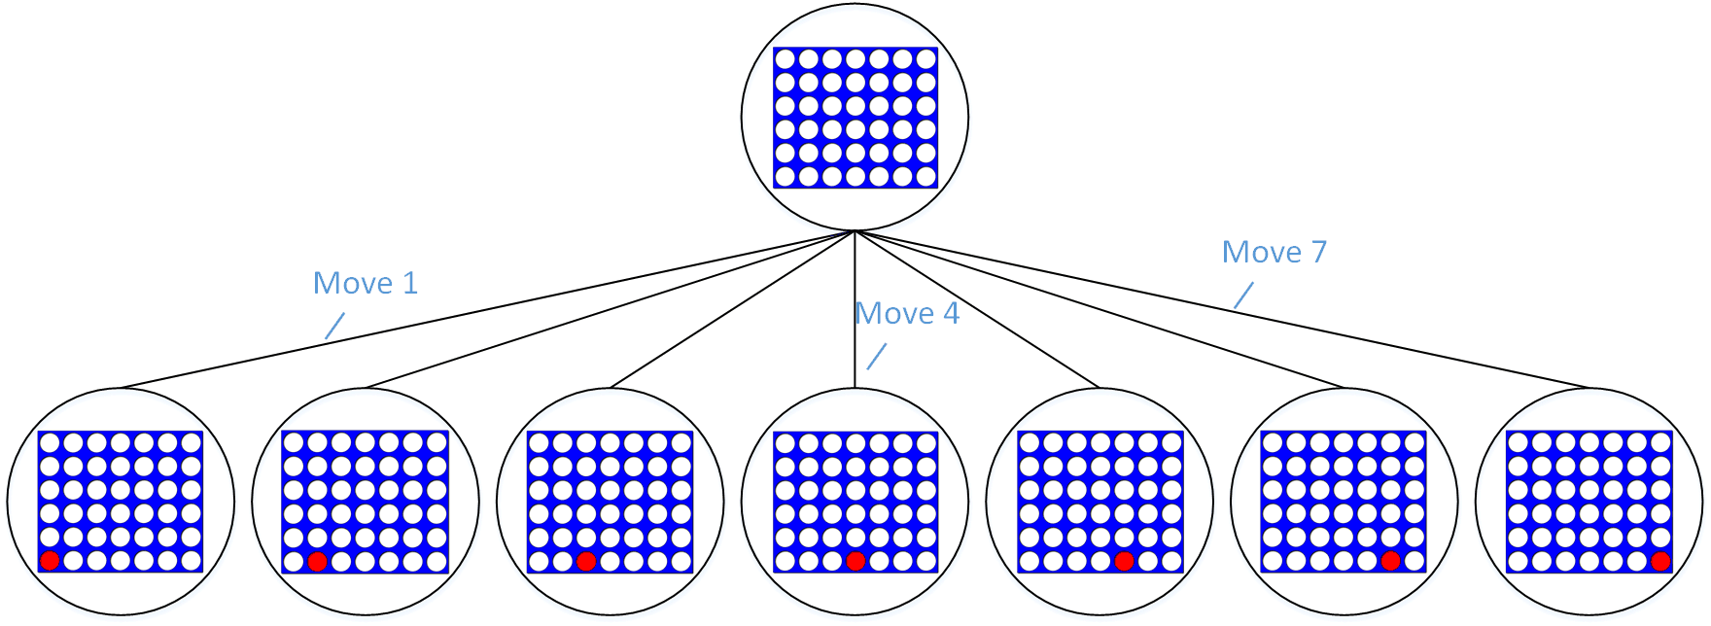
Connect4 is a game with a large playing space and has a massive, yet still finite state of game spaces it can be in. I chose this game for the project as it would be able to show off the algorithm's complex decision-making capabilities while still being fairly easy to code and work with. The initial game state starts with an empty board, each disc that is dropped into a column creates a new game space.
Games like tic-tac-toe have a much smaller playing area and therefore have a much smaller game tree.
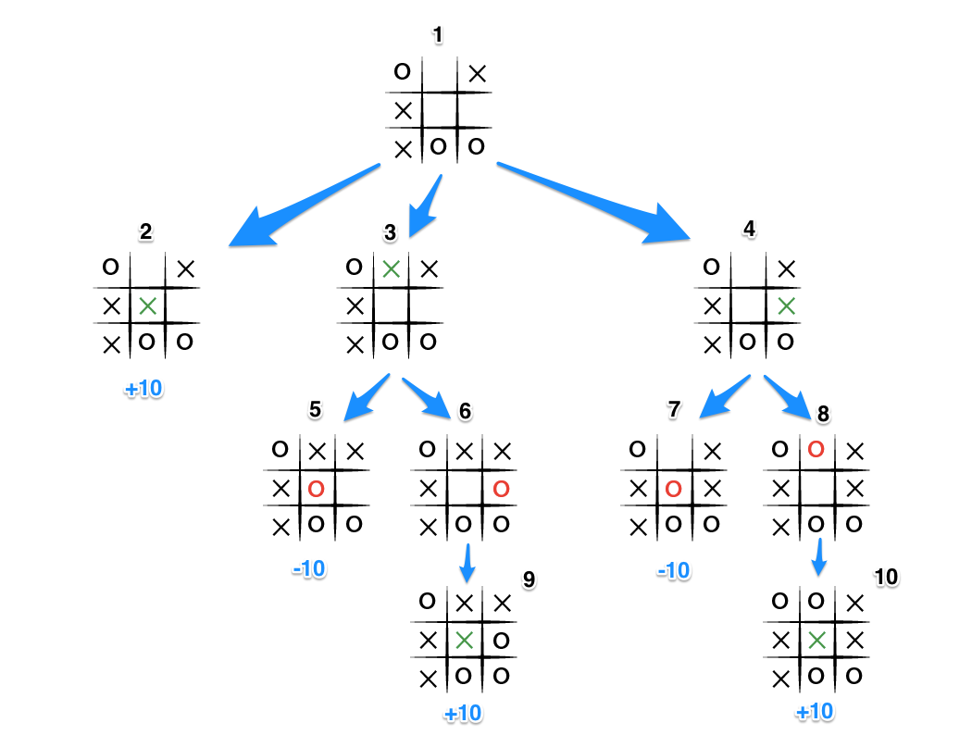

Code
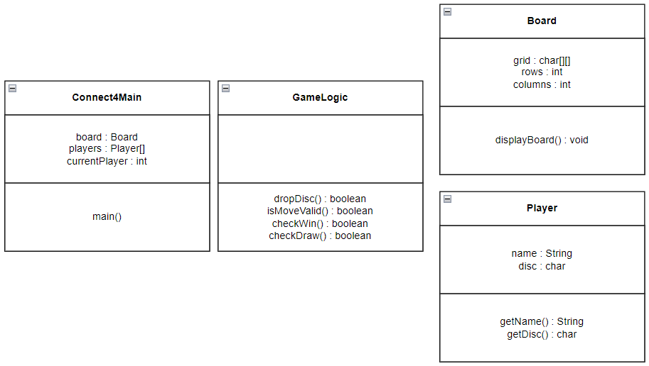
Above is the original rough UML I created to begin the code with. I had a class for the board, the player and the actual game, I also created a class for the game logic to keep these methods separate as I thought putting them in the main or board classes would add unnecessary functionality to those. The idea here was that the main class would run the flow of the game, initialising the players and asking for their names, player one having the red disc and player two having the yellow disc, then creating the board and displaying it, asking the players to drop discs and switching players, checking for a win or draw condition each turn.

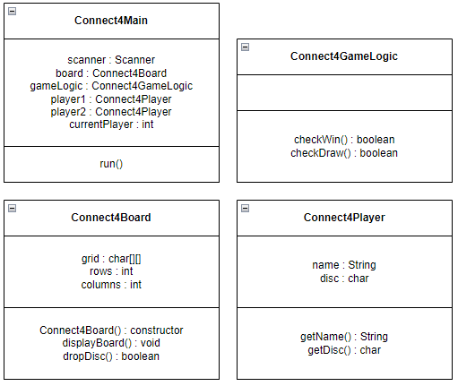

A few things have been changed while coding from the original UML. The names of the classes have been changed as this proof of concept code has been added with the bandit problem proof of concept code and I changed the class names to reduce confusion as to which class belongs to which program.
The next big change is moving the dropDisc() method into the board class, I decided to do this to make writing the method easier, as this method directly interacts with and changes the board I thought it would be better to have it in the board class. I removed the isMoveValid() method as it was only checking where the column input was in range and not full and so I added this code straight into the dropDisc() method instead.

Monte-Carlo Tree Search Algorithm
Monte-Carlo Tree Search is an algorithm known for its ability to effectively handle complex and strategic games that have a massive number of available game states. Unlike other, older search algorithms that use exhaustive search methods over the entire game state area, Mont-Carlo uses methods that narrow down the states and explore the most promising sections [1]. This also makes MCTS a great algorithm to use for games with unknown states, as it relies on statistical sampling as opposed to fully known game states.
It applies Monte-Carlo standards to tree based search techniques. Monte-Carlo simulations are used as a way to model probabilities of different outcomes in processes that cannot easily be modelled and predicted as a result of random states and variables. These simulations can be used to explain the impact that the risk of uncertainty have on certain models. [4]
The main idea of MCTS is to build the tree of game states incrementally. This is done by simulating a number of games, picking random moves until a win condition is met, and then calculating which of the next nodes have the best result depending on which one led to the most win conditions and expanding the tree to that one, making a move to reach that desired game state.
As the tree grows MCTS balances the use of exploration of new, promising nodes, and exploitation, the repeated use of nodes that have given back good results. This balancing is done through the usage of Upper Confidence Bounds (UCB); which is an algorithm I have covered in the bandit problem proof of concept. UCB contains a mathematical equation for calculating which node is the next best one to go to.

The Algorithm
The main state of Monte-Carlo Tree Search is a search tree. Each node in the search tree is chosen and added based on the outcome of a number of simulations run on the unknown game states [1]. The MCTS algorithm can be explained in four different states:
- Selection: This section of the process traverses the tree, beginning at the root, using a specific strategy. This strategy uses the UCB formulae to select the best nodes to traverse next.
[EXPLANATION OF UCB HERE] [1].
The child node that is deemed to have the highest UCB value is selected. During this stage, if a node that is traversed to is a leaf, we go to the next stage in the process.
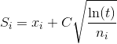
- Expansion: In this process, a new child node is added to the tree to that node which was optimally reached during the selection process. [1]
- Simulation: In this process, a simulation is performed by choosing moves or strategies until a result or predefined state is achieved. [1]
- Backpropagation: After determining the value of the newly added node, the remaining tree must be updated. So, the backpropagation process is performed, where it backpropagates from the new node to the root node. During the process, the number of simulations stored in each node is incremented. Also, if the new node’s simulation results in a win, then the number of wins is also incremented.
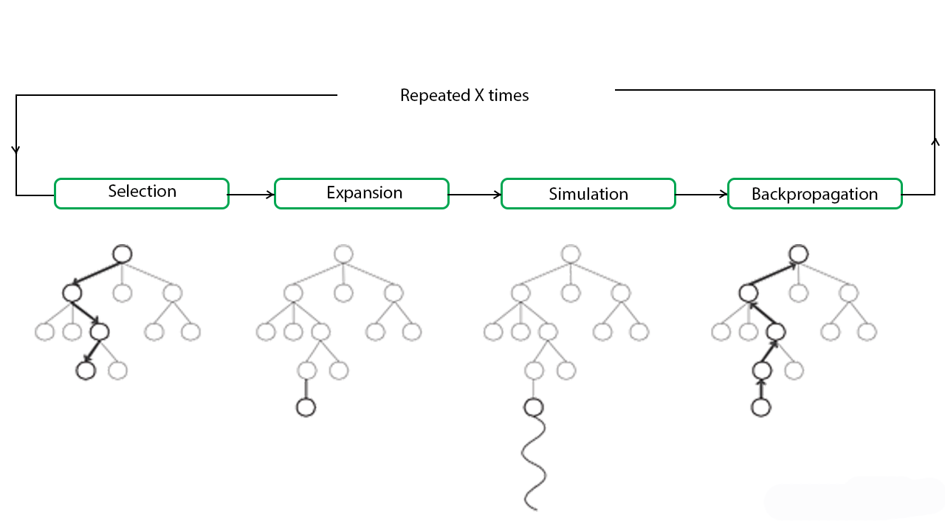

Integration into my program
How I used the proof-of-concept codes and MCTS to create the final product. Kind of an intro to next section.

Final Product
Showing code and GUI, how everything works and interacts. Showing the old vs new proof of concept codes and how they were used, how I integrated the algorithm.

Testing
DO SOMETHING!
Did bug fixing along the way [kinda], talk about that!.

Software Engineering Techniques
Talk about software engineering techniques in general, and then discuss the ones you used in more detail.

Professional Issues
Revisit the page on moodle for this.

Reflection
Talk about everything you did wrong.
- Planning should have been more detailed
- Should have documented things as I went along as that would have been much easier, like showing the gradual implementation of the GUI and the code.
- Should have used more software engineering techniques

Conclusion

Deploying Code
How to install java fx to run the code.

Bibliography
- geeksforgeeks (2023) ML | Monte Carlo Tree Search (MCTS). Available at: ML | Monte Carlo Tree Search (MCTS) - GeeksforGeeks
- Guillaume Chaslot, Sander Bakkes, Istvan Szita and Pieter Spronck(2008) Monte-Carlo Tree Search: A New Framework for Game AI. Available at: (PDF) Monte-Carlo Tree Search: A New Framework for Game AI.
- (PDF) Bandit Based Monte-Carlo Planning
- https://www.investopedia.com/terms/m/montecarlosimulation.asp

